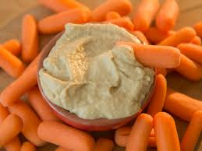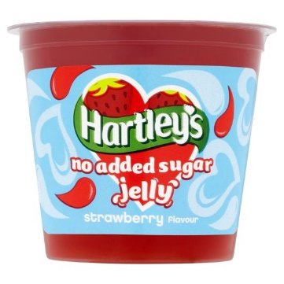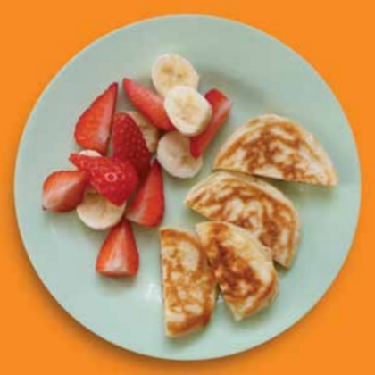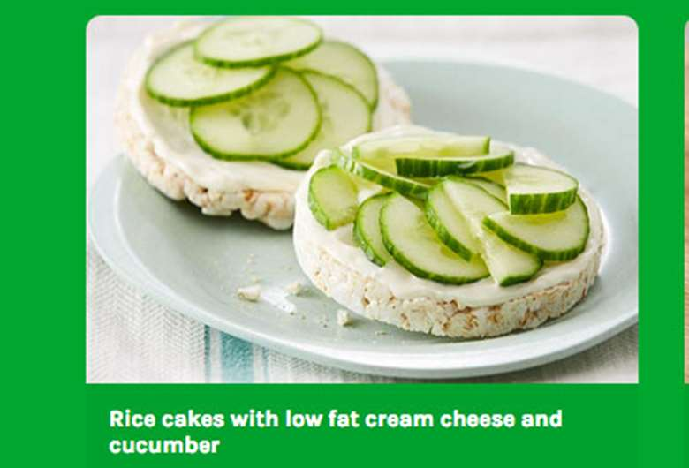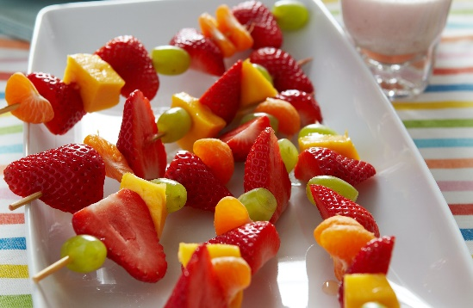

Low Fat Houmous – Take 2-3 tbsps of houmous and pop into a small bowl. Chop up veg like carrots, peppers or cucumber or a few breadsticks to dip in.

No Added Sugar Jelly – Pop into a bowl and add in fruits to give a different texture. For an extra treat use a squirt of low fat squirty cream.

Scotch Pancakes with fruit – You could make the pancakes together with your child and get them to decorate, give them a task to make a smiley face from the pancakes and fruit.

Rice Cakes with Low Fat Cream Cheese – get your child to help spread the cheese on the rice cake and add their favourite healthy topping like cucumbers or tomatoes.

Fruit Kebab – add your child’s favourite fruit to a stick for a healthy treat. Try freezing the fruit to give a refreshing taste in the warm weather.

**Snack Ideas for Children**